SEVEN HIGHLIGHTS FROM 2017

God continued to bless TIBI in 2017. Here are seven reasons for praise and rejoicing from this year:

- There were 514 baptisms this year at sites where TIBI helps train leaders, making a total of 3150+ since 2009. (left, below)
- For the first time, a TIBI graduate returned to teach a TIBI course--Bernie Villalobos from Costa Rica. We are proud of Bernie for his high-quality character and work. (Below, right)

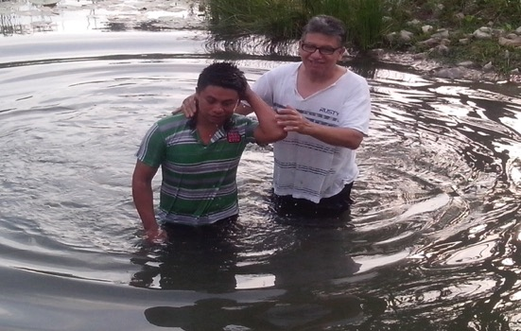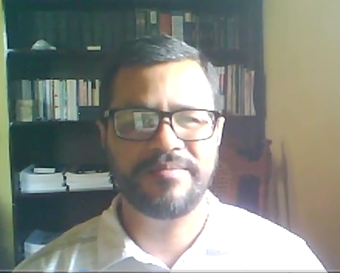

- TIBI switched to Zoom for as our new video conferencing system, resulting in a complete upgrade in every way. Now we can have up to 2000 sites connected at one time! (below, left)
- Our YouTube channel (below, right) has more than 485,000 views and 4440 subscribers.

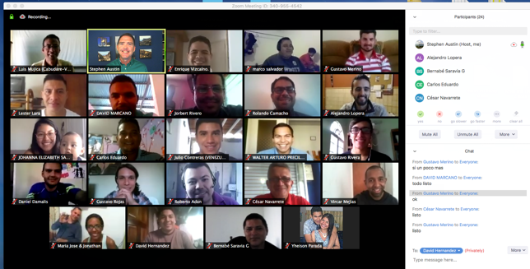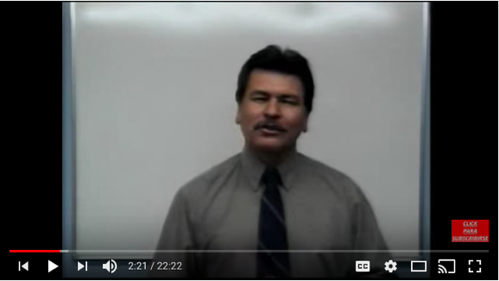

- During our 6th sponsored Israel trip in June, we were able to film clips for more than 50 teaching videos in English and Spanish, in a new 360-degree format, available on our channel (below, left)
- We enjoyed our largest number of graduates, incoming students, and total students, with a net growth of 700 students from last December. (below, right)

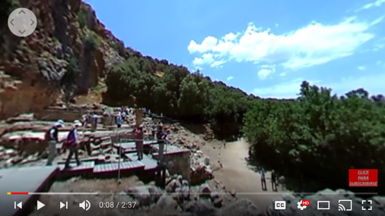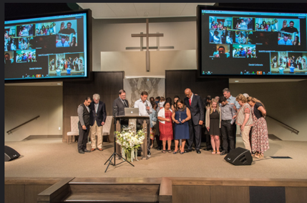
- This year we laid the groundwork for exciting work in 2018—partnering with other schools to begin a Masters of Practical Theology, and also finishing the Cuba evangelist training project.

God is good! Please continue to pray for us as we move forward. If you’d like more information about TIBI, or if we can help you, please contact me at slaustin@cebridge.net, or (281) 787-3721.

Steve Austin

