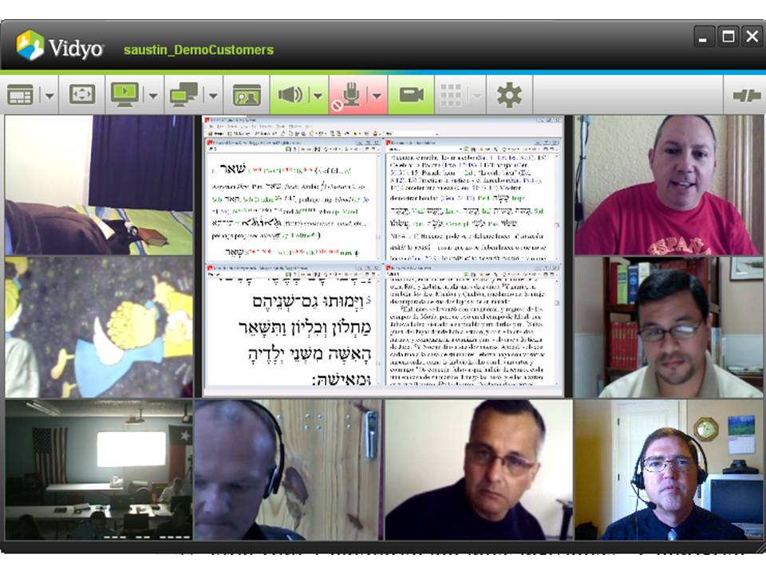
The TIBI
HERALD

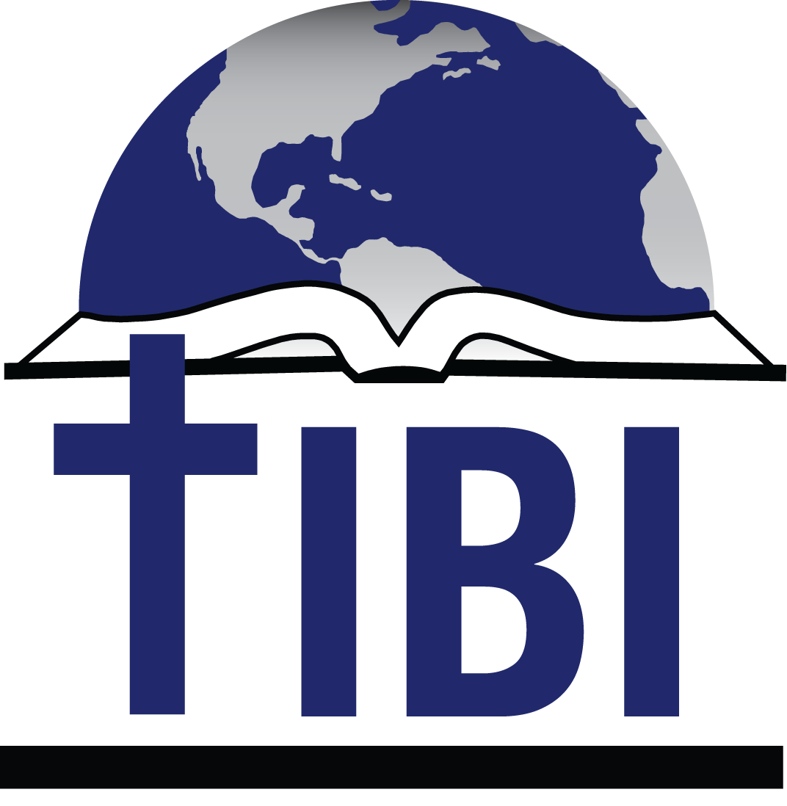

Editor
Steve Austin
Volume 14, Issue 1
March 22, 2017

THIS ISSUE

Who is TIBI?
Daniel Urdaneta
Carlos Camacho
Kevin Montgomery
Pedro and Silvia del Pozo
Steve Austin

“I thank my God every time I remember you…I always pray with joy because of your partnership in the gospel from the first day until now.”

Ps. 133:15

Texas International

Bible Institute

P.O. Box 1501

1502 Avenue I

South Houston, TX 77587
(713) 910-2819

Video Archives: 216.69.244.244
Online video courses at es.sunsetonline.org
YouTube IBIT

kevin@texasbible.org

sraustin@texasbible.org

texasbible.org (English)
es.texasbible.org (Spanish)
ibitibi.org (brand-new site)

Who is

?

An easy question—yet a multi-faceted one. Since its beginning in fall 2002, TIBI has been an organization dedicated to training disciples of Jesus Christ, who can train other disciples, planting biblical, relevant, fruitful churches. That mission continues.
Now with more than 1800 students in at least 95 countries, TIBI is also its students—from 12 years old to 80 years old, men and women, white collar and blue collar, full-time and part-time, new Christians and those with decades of service in the church, representing various races, dialects, backgrounds, and experiences.
TIBI is its faculty—men who have acquired academic knowledge and ministerial expertise for many decades in at least 6 countries, honing those skills in order to transmit them to our students.
TIBI is also its supporters—our board, elderships, churches, donors--who have overseen and provided faithfully for the people, programs, and needs of TIBI. God has been so generous through you to help us reach his goals. We value your collaboration, encouragement, and prayers.
And TIBI is also its staff—at present a group of 6 individuals who function in a cohesive, efficient fashion. We are from different backgrounds and bring varied skill sets to TIBI, but mesh well together to achieve our mission. It’s possible you may not be aware of who they are and what they do, so in this issue we’d like to paint you a picture of this wonderful group of people who have given a total of 52 years of service to TIBI!


Daniel Urdaneta
Daniel and his wife Loli are originally from Venezuela. Daniel moved to Florida and lived in Miami and Orlando for several years, where he had his own computer support business, and he and Loli were actively involved in churches in those two cities.
After several years, they felt the Lord wanted them to begin a church in Spain, where the church has struggled for many years, as in much of Europe. So they moved to Valencia, Spain. When TIBI began its international program, Daniel applied for a full-time study scholarship and was part of our first international class of graduates two years later.
As our program continued to expand, and we changed video conferencing systems, we needed another person to handle some of the ongoing tech work, which was growing by the month. So in the fall of 2013, we invited Daniel to work as our part-time IT specialist.
He helps maintain our Vidyo system, trains new users, keeps current users up to date in tech and billing, and helps update our mass email system. Along with Silvia (see below), he keeps our Twitter and Facebook accounts active, always recruiting new followers and doing PR work about TIBI activities. Recently he took the initiative to help TIBI transition to a totally new website and format, doing most of the work on that (ibitibi.org). Of course, he does a lot of troubleshooting as well in each of these areas.
From his beginning as a student till now, his willingness to learn and help others in any way has been one of his defining characteristics, and this has been a blessing for us. We are glad to have him!

Carlos Camacho

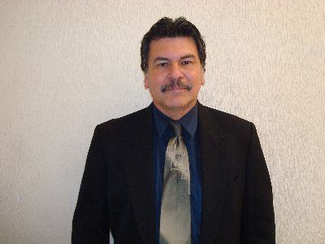
Carlos and his wife, Gabriela, and family are from Venezuela. Carlos has more than 30 years in successful church ministry, helping nurture two congregations to grow to more than 200 members, and develop their own elders, deacons, leaders, and become self-supporting. One affirmation of his effective work is that almost 10 years after he left, the churches are both still going strong.
Carlos came to work full-time at TIBI in May 2009. His role is that of fieldwork supervisor. He mentors all of our full-time scholarship students each week one on one or in small groups. He focuses on their spiritual lives, on their relationships with other Christians and leaders in their congregations, helps plan strategies for their discipling and ministry, and helps troubleshoot problems that may arise. He teaches our small groups courses, and some textual ones also.
Carlos and I have also been to Cuba several times together, in order to implement our Cuban evangelist training program. He has great compassion for people, encourages fellowship and genuine love, and is a gifted teacher, preacher, and small group facilitator. We are blessed to have Carlos as well.

Kevin Montgomery

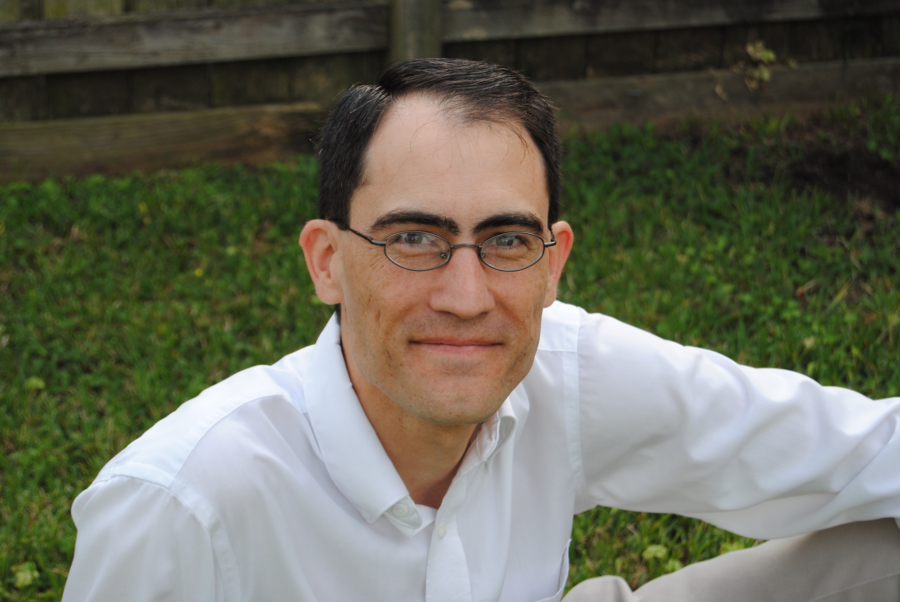
Kevin and his wife Alicia and daughter have an interesting history. Originally from Houston, Kevin received degrees from Texas Tech and Sunset International Bible Institute. He and Alicia both served as AIM students in Chemnitz, Germany, and were married soon afterwards. Kevin also served in the Montwood Church of Christ for several years in El Paso with the Latino group.
In June 2008, Kevin came on staff full-time at TIBI as assistant director. He teaches our Greek and Exegesis/ Hermeneutics courses, as well as several others. He also manages the day by day finances and other local duties at our original school base in South Houston.
Kevin is one of those people everyone likes—rare as they are! He is kind, compassionate, and affirming. He is thoughtful and wise in giving considered opinions, based on the Word of God and his experience. He tries to sincerely live out his Christian witness any way he can—and succeeds. I am grateful to have him, and rely on him daily.

Pedro and Silvia del Pozo

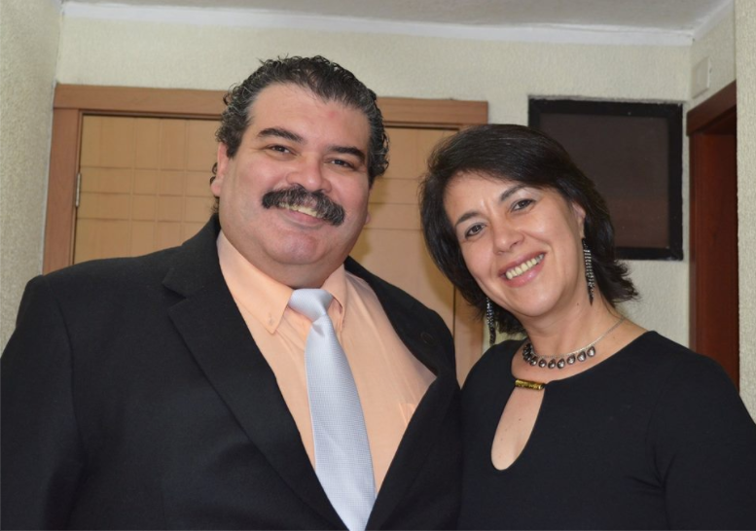
Pedro and Silvia are originally from Argentina and Uruguay, respectively. They were married in Buenos Aires in the early 90s and have been active in their congregations for decades. In 2004, they applied for and received a scholarship to study Bible and ministry full-time at the Quito School of Biblical Studies, where they graduated near the top of their class in 2007.
Since I had known them since the 90s, I knew their character and talent, and invited them to help us begin our online video course program when they graduated in June 2007. In the 10 years since, we have almost completed putting all 40 courses online. They lead and develop that program with more than 900 students, and as we finish, they will also help lead the next phase of developing local schools in many churches in Latin America using those courses in a different fashion, even where there is not good internet.
Pedro and Silvia are some of those rare people who can see both the big picture and the smallest detail, and work effectively in both. They have excellent tech skills, and the perseverance so needed to carry these projects to a successful conclusion. I trust them implicitly.
Steve Austin

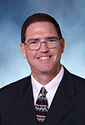
I am the founding director of TIBI, which began as a dream just for Houston in fall 2002. I received my undergraduate and postgraduate degrees from ACU. My wife Lynette and my family have served in Latino ministry and missions in Argentina, Houston, and now at TIBI.
I came on full-time at TIBI in June 2005. I remember clearly my first day in that small building in South Houston. After I had lunch with our board, everyone left, and I looked around me—tile floor, empty desk, empty bookcases, no chairs, no tables, no tech, boxes of books and materials—and my mission from the board to make TIBI a place where we could train men and women to be disciples of Jesus and plant Latino churches.
It’s amazing what the Lord has brought about in those 12 years. My days are spent in teaching, administration, networking, studying, fund raising and PR, and I’m content and grateful.
(Kevin) God has used Steve to inspire and to lead the charge of this ministry since its inception. Steve is gifted with great insight, indefatigable dedication and a constantly expanding vision for the future, allowing God to use him mightily as a leader. TIBI would not be the same without him, and the rest of the staff thank God for his talents and character.
I am so blessed to work with Daniel, Carlos, Pedro, Silvia, and Kevin. What a wonderful group of people! We are a team which complements and challenges each other. We make major decisions together and then trust one another to fulfill our own individual roles. We are separated by the miles between Spain, Ecuador, Mexico, Houston, and Abilene—but we are powerfully united, supported by the Lord and you. I pray that God will give us many more years of growth, challenge, and success in his Kingdom at TIBI, all under his will and guidance.

Texas International Bible Institute
1502 Avenue I
South Houston, TX 77587

