The TIBI
HERALD
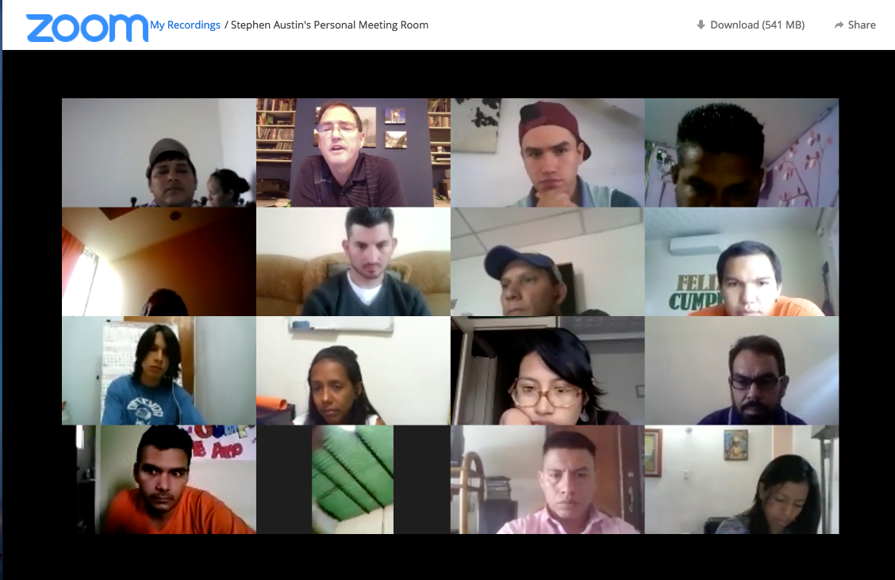



Editor
Steve Austin
Volume 14, Issue 3
October 12, 2017

THIS ISSUE

TIBI welcomes largest class
We’d like to introduce
to you…
360 degree Israel videos

“What you have heard from
me, keep as the pattern of sound teaching, with faith
and love in Christ Jesus.”

2 Timothy 1:13

Texas International

Bible Institute

P.O. Box 1501

1502 Avenue I

South Houston, TX 77587
(713) 910-2819

Online video courses at es.sunsetonline.org
YouTube IBIT

kevin@texasbible.org

sraustin@texasbible.org

texasbible.org (English)
es.texasbible.org (Spanish)
ibitibi.org (brand-new site)

TIBI welcomes largest class
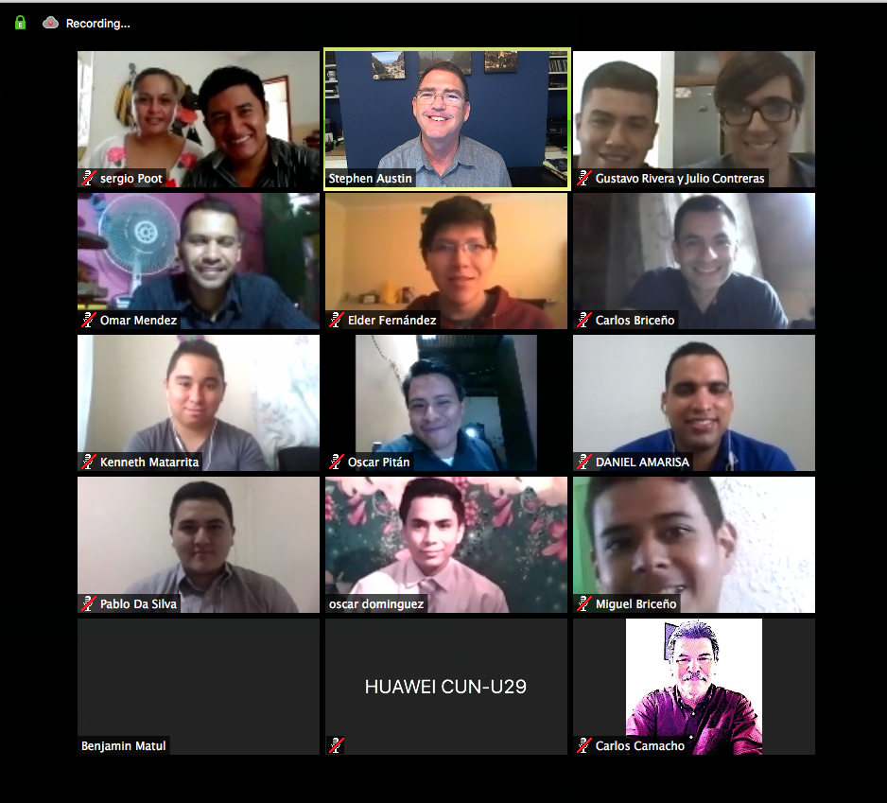
New student orientation, August 11

On August 11, TIBI welcomed its largest incoming class of students, with 15 in all, plus the wife of a scholarship student who is studying part-time while working full-time. These students were selected at the culmination of a long, arduous process. In addition to completing an 11-page application, they had to take a demanding course online in 40 days, in order to show their academic and technology skills, as well as their organization and discipline. Then they did a practical field work assignment which demonstrated their interest in and skills with a simple evangelistic project. Those who completed those tasks satisfactorily were invited to a Zoom interview with our five-member administrative team, so that we could get to know them more face to

face, and ask questions based on the process they underwent. Of the 46 candidates that began, 11 received full-time scholarships. Then two of the wives committed to studying full time with their husbands, and two more students were sponsored by others to study.
We are very pleased with this group. As I write this, the students, along with the second-year class, have just finished the Fall 1 cycle of courses, including difficult classes such as Hebrew 1. They have acquitted themselves very well, with all them passing, and most getting As or Bs. They are very pleasant to deal with in class, and work well together as a group, even scattered out among different countries. They have been cooperative, eager to learn, and eager to apply what they are taught.
With this group, we now also have our highest total number of full-time students-29 in all, plus several other part-time students taking some video conferencing classes. They represent 10 countries in Latin America. Then we have students from at least three other schools sharing some of our live courses as well. Teaching and interacting with these students in class and activities is my very favorite part of my job, and I’m grateful to the Lord.

We’d like to introduce to you…
We’d like to tell you a little about each new student, and their wives when possible. Benjamin and Belen, as well as Oscar and Lilian, are our first full-time scholarship students from Guatemala. They work with the Villa Nueva congregation in Guatemala City. Carlos and Kemberly Briceño both study full-time, and they are helping establish a new work in Timotes, in the Venezuelan state of Merida.



Benjamin and Belen Matul Oscar y Lilian Pitan Lopez Carlos and Kemberly Briceño
Daniel and Claudia Amarista live in the city of Carupano in Venezuela. They have worked with a highly evangelistic group which has helped establish 8 congregations in and around Esmeralda, and they help with several of those. Gustavo and Gabriela Rivera were just married last month, and they are with the La Bonita church in a suburb of Caracas. He already took several courses before becoming a scholarship student this year. Julio Contreras is engaged to Laudymar, and had also been studying with us since August 2016 on his own account. He has helped with congregations in San Cristobal, Barinas, and now in the Bumbum congregation, all in Venezuela. Miguel Briceño is from Valera, but commutes to work with the Boconó church a couple of hours from Valera, Venezuela.
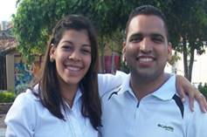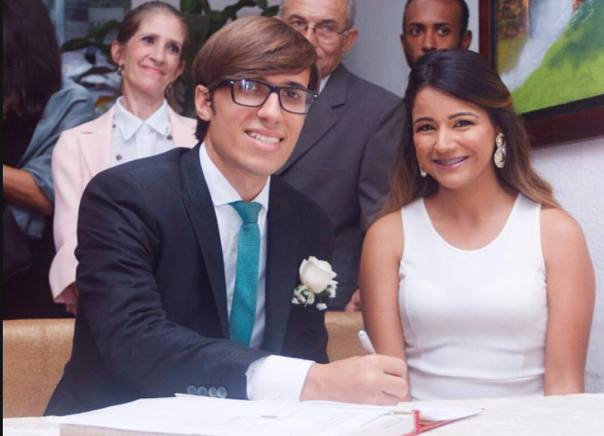

Daniel and Claudia Amarista Gustavo and Gabriela Rivera

Omar and Marly Mendez live in the large city of Barquisimeto, Venezuela. Omar was a captain in the Veneuzelan army, but retired to be able to dedicate his work full-time to the church. He now helps in a congregation established in Los Sauces.



Miguel Briceño Julio Contreras and fiancee Laudymar Omar and Marly Mendez

We are also pleased to share that we have our first full-time students from Bolivia this fall. Pablo and Dahiana live and work with the Centro church in Cochabamba, Bolivia. Pablo is actually from Brazil, and has done an AIM internship in Paraguay. We hope some day he might return to Brazil to share what he has learned at TIBI also. And Elder Fernandez lives in the city of Sucre, Bolivia, and works with the church there.

Pablo and Dahiana Yuri Silva Elder Fernandez


Sergio and Dulce Poot Oscar and Cristian Artola Kenneth and Darlin Matarrita

Finally, we welcome Sergio and Dulce Poot, who are both full-time with us, and work in the city of Campeche, Mexico with another graduate of TIBI, Juan May Che. We also are glad to have Kenneth and Darlin Matarrita, who work in the congregation in Heredia, in northern San Jose, Costa Rica. And from Tipitapa, Nicaragua, studying on his own account, we have Oscar Artola Dominguez. We ask you to pray for this class in their studies, their work, and—for many of them—their new marriages! God is good.

360-degree Israel videos
We also want to share that we’ve finished editing our latest video project from Israel, a collection of 54 videos shot in 360-degree video format. There are approximately 35 sites included, and these are a great resource for understanding what sites looks like in their full context. You can see them on TIBI’s YouTube channel at https://www.youtube.com/watch?v=pM4CKqxyrAQ&list=PLj1nkTHfZxM3m_2Y9DxYZ9cSkpb3JLcTK

Texas International Bible Institute
1502 Avenue I
South Houston, TX 77587

