The TIBI
HERALD
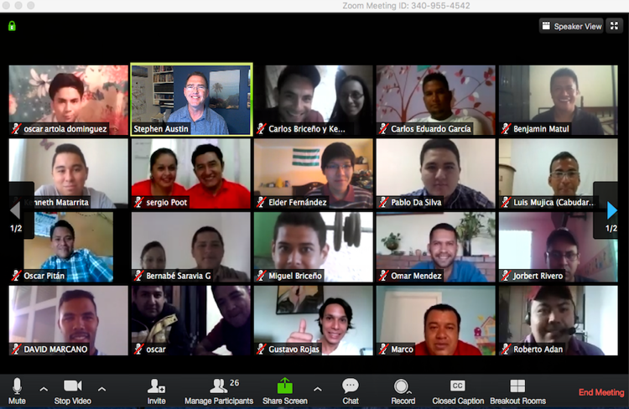



Editor
Steve Austin
Volume 15, Issue 1
March 16, 2018

THIS ISSUE

Triple blessing
Harvest in Cuba
In case you missed it…

“How beautiful are the feet of those who bring good news…”

Isaiah 52:7, Rom. 10:15

Texas International

Bible Institute

P.O. Box 1501

1502 Avenue I

South Houston, TX 77587
(713) 910-2819

Online video courses at es.sunsetonline.org
YouTube IBIT

kevin@texasbible.org

sraustin@texasbible.org

texasbible.org (English)
ibitibi.org (brand-new site)
www.redinbi.org (Masters)
Triple Blessing!
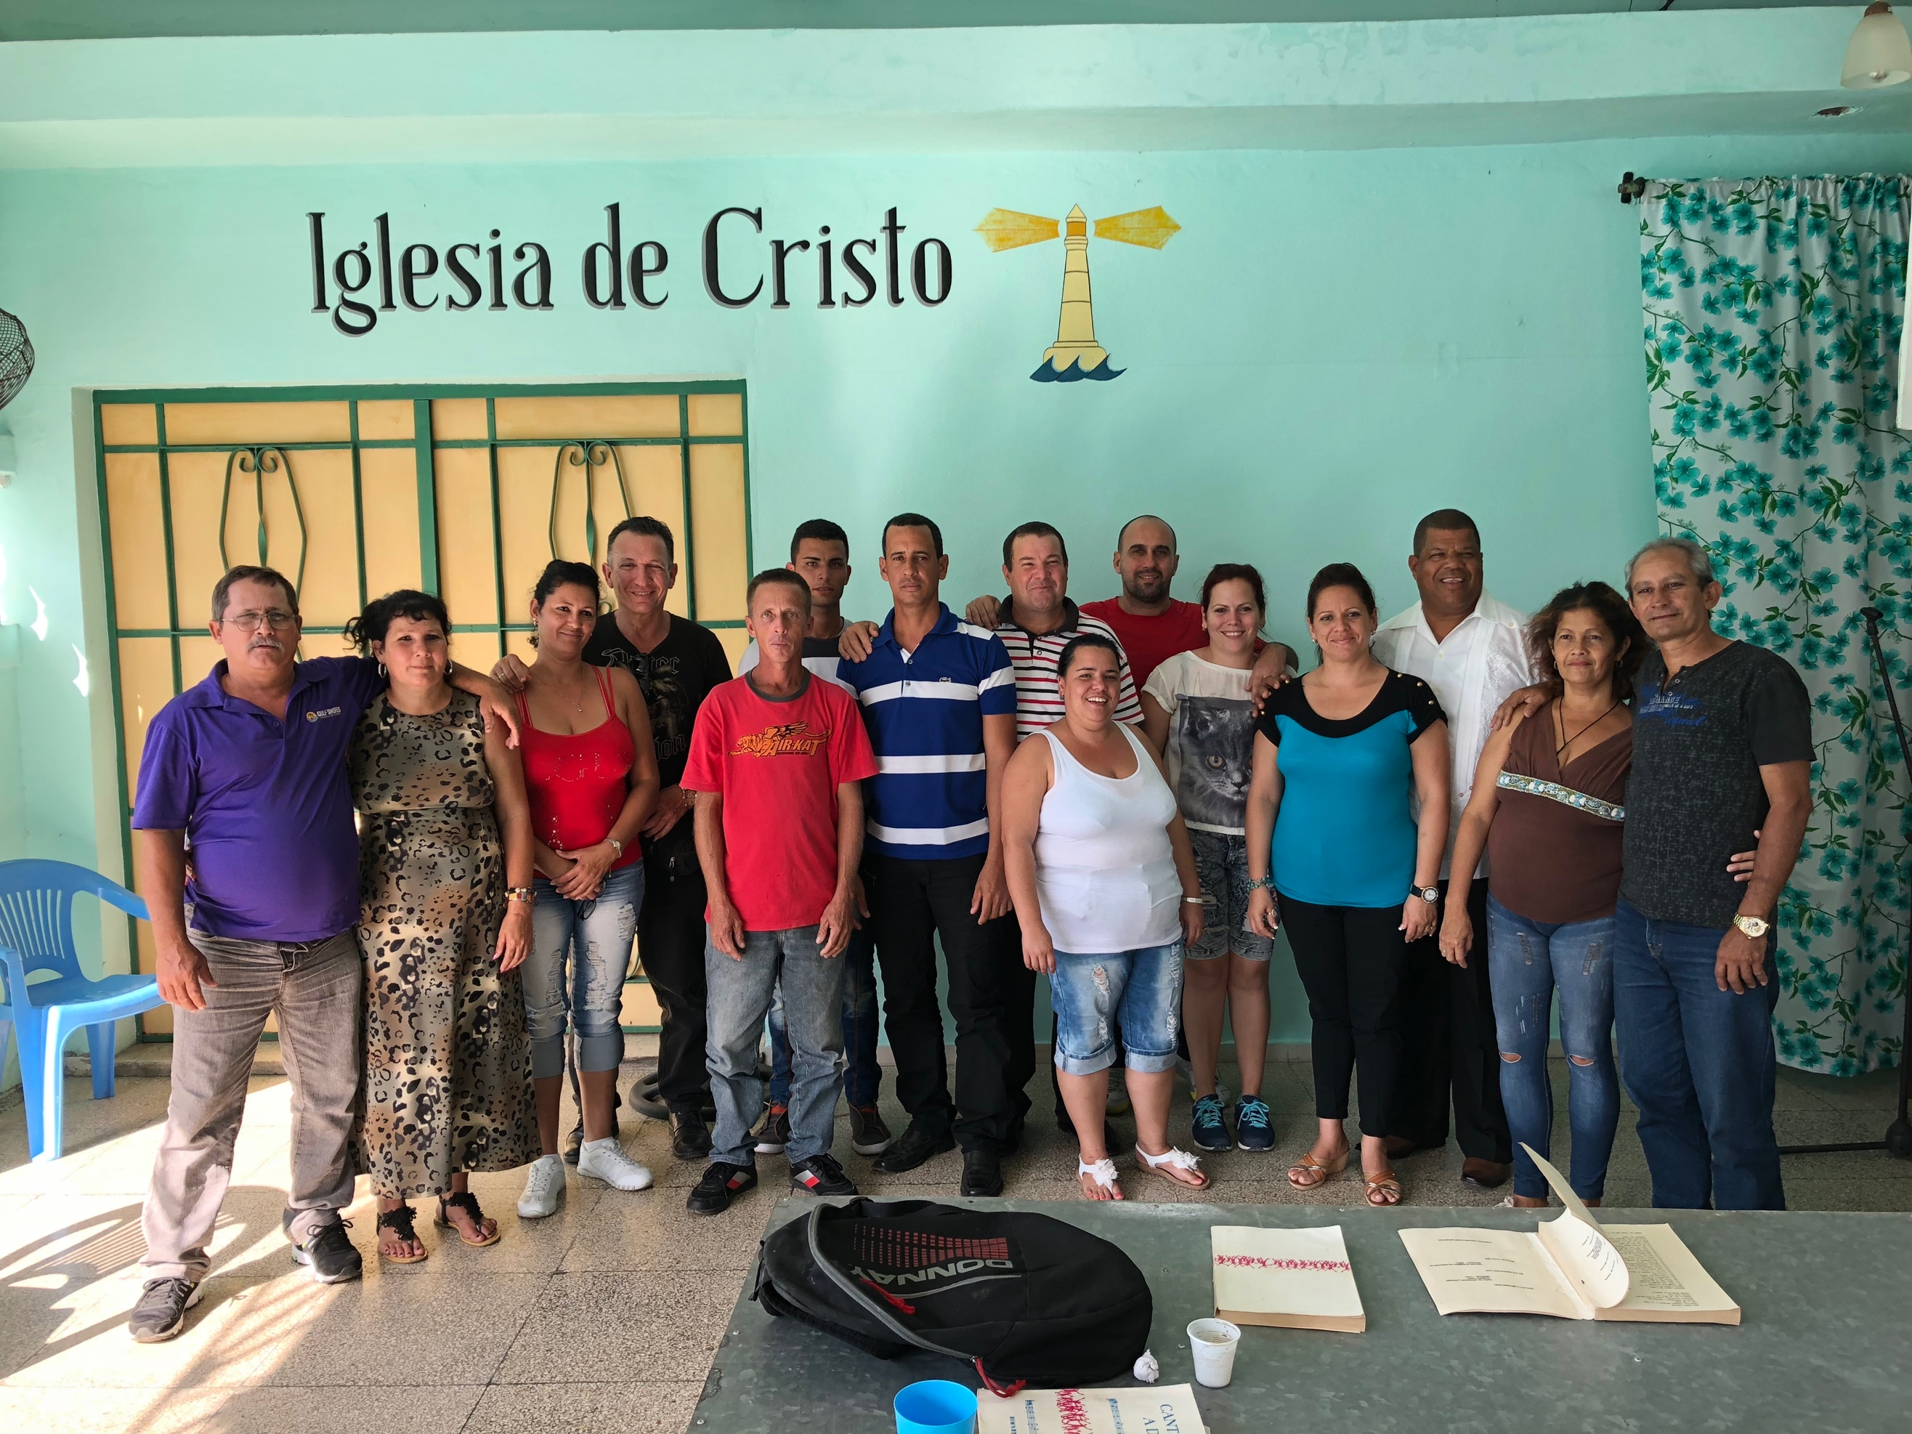
Third group of Cuban evangelists (l to r): Antonio and Yohania, Marilin and Barbarito, Lioneysi, Yoelvis, Idel, Jorge and Dayami, Samuel and Jany, Daily and Pablo, and Maria Magdalena and Osmany.

Romans 10:15 says, “How beautiful are the feet of those who bring good news…”. The origin of that quote in Isaiah 52 is from a time when many in Israel were unfaithful to God, and the Lord said, “All day long my name is constantly blasphemed. Therefore, my people will know my name…How beautiful on the mountains are the feet of those who bring good news, who proclaim peace, who bring good tidings, who proclaim salvation, who say to Zion, “Your God reigns!”
The ones who would help restore God’s name among the nations and bring hope and life to Israel were those who spoke truly of God and his salvation. Today, in the communist country of Cuba, where God’s name has often been ignored or blasphemed, there is now freedom to proclaim good news again.
TIBI is excited to join in this proclamation. In late February, Carlos Camacho and Steve Austin went to Matanzas, Cuba, to begin training the third group of Cuban evangelists. We have been blessed to work with two other groups, 14 people in all. This third group had 15 in all—six couples and three single men. These men and women are already respected leaders in eight congregations from three provinces of Cuba.

They come from an amazing variety of backgrounds. There was a judge and a lawyer (husband and wife); the couple who run the farm for the Versalles church; a baker; a nurse, an accountant; and a teacher, among others. Their ages ranged from 20s to 60s.
We spent about 30 hours during 5 days, getting to know them, their stories, their congregations, and their dreams. We talked about the core message of the gospel, examining their essential beliefs and how they arrived at them, including the major influences that shaped their doctrine and practice. We discussed the Bible—how they interpret it, how it relates to Jesus, and what role it has in their lives and ministries.
We also presented various scenarios we had experienced in ministry and church life—ours and theirs—and how they might share the gospel with people in those scenarios. We role-played with them as atheists, agnostics, burned-out Christians, musicians, homeless, drug addicts, tourists, fathers and mothers, even as Donald Trump (ok, that wasn’t from our direct ministry experience!) Then we would discuss things they did well, and also suggestions to improve in each case. It was instructive to see how they interacted.
In October, Lord willing, we will return for the second and final week-long seminar with them. In the meantime, we gave them these tasks: (a) to maintain a genuine devotional life with the Lord; (b) lead a weekly cell group focusing on nurture and evangelism; (c) select and train an apprentice in the same areas we cover with them; (c) have at least one evangelistic study per week, and (d) keep us informed of their progress. We also gave them a small stipend to help with living expenses and a small work fund—in Cuba these funds go a long way.

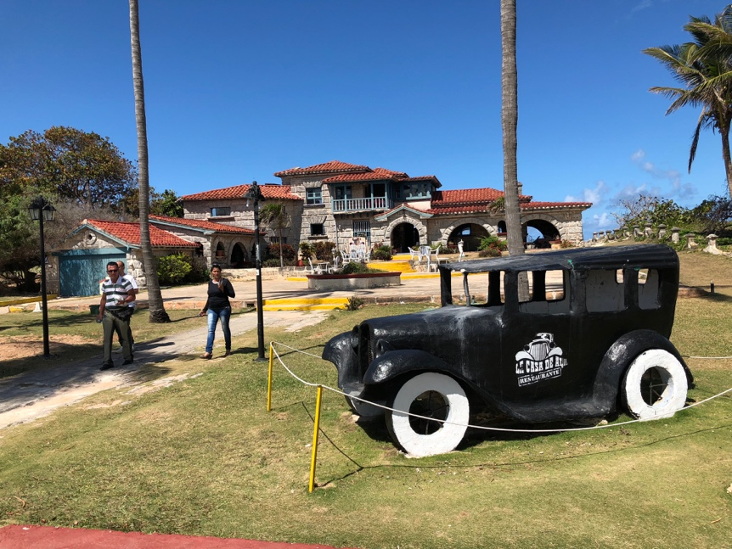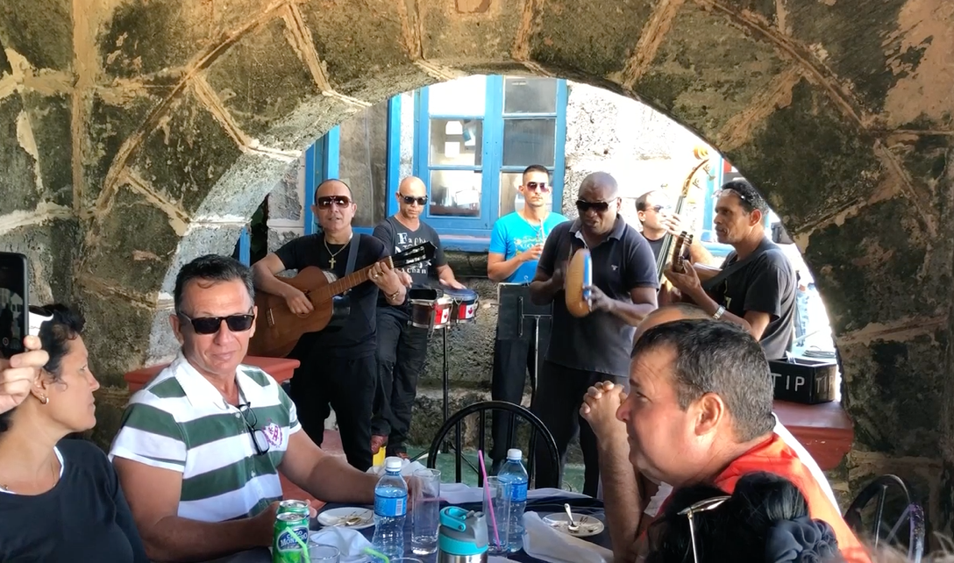
Al Capone’s former house Music, food, and fellowship

On the last day, we celebrated the close of the seminar with lunch at what used to be Al Capone’s house on the beach at Varadero, enjoying the sun, food, and music of a classic Cuban group. We ask you to pray for each person and their work: Antonio and Yohania, Marilin and Barbarito, Lioneysi, Yoelvis, Idel, Jorge and Dayami, Samuel and Jany, Daily and Pablo, and Maria Magdalena and Osmany.

Harvest from Cuba
Since this was our third group, while we were in Cuba we also had the opportunity to visit with some of the previous evangelists we helped train. For example, there is a man named Pedro Luis, a Christian in Colon, a major city of the province of Matanzas, about 60 miles from the Versalles church. Tony Fernandez and a number of Christians helped re-establish this congregation a couple of years ago. Now Pedro Luis has planned and is executing an aggressive program of evangelism in Colon and the surrounding area.
When Tony, Pedro, and the Versalles mission team began to work in Colon, there were two tiny congregations who had separated from each other, angry, ignoring each other. Tony began to preach love to them, telling them, “If you all don’t love each other, what is the use of our coming and helping you?” Slowly they reunited, and now there are 60-80 Christians in that church. In addition, they have begun three other congregations at various points of the compass around Colon. They have planned three more, for a total of 7 in that area.
On the Sunday we were in Cuba, we visited the Colon and the Santa Gertrudis congregations. In Santa Gertrudis, a small house church of 12, while we were singing in the service there, I looked and saw the elements of the Lord’s Supper on a table there—the plate with the bread, and the tray with cups. But then behind the tray I saw a half-full bottle of Havana Club rum! I thought, “No…surely not…how do you get from ‘fruit of the vine’ to rum?!”
Tony leaned forward just then and whispered in my ear, “Steve, sometimes it’s hard to get wine in Cuba. Would you be ok with rum?” But it turned out, as I took my little cup, it was only wine—but kept in the rum bottle! Tony texted a picture of it to several friends in the US. One of them texted back, “Maybe Jesus turned the RUM into wine!” A humorous moment—and it was wonderful to meet those new brothers and sisters, truly a highlight of the trip. I learned that the next Sunday, Colon celebrated 6 baptisms, including some of the visitors to the Santa Gertrudis house church that day.

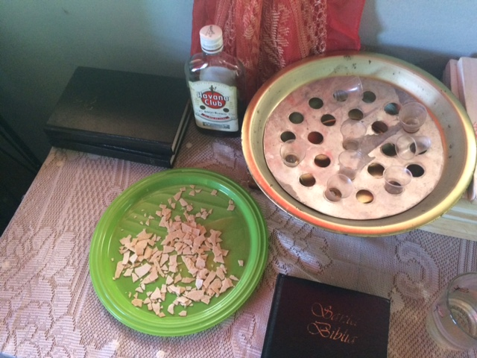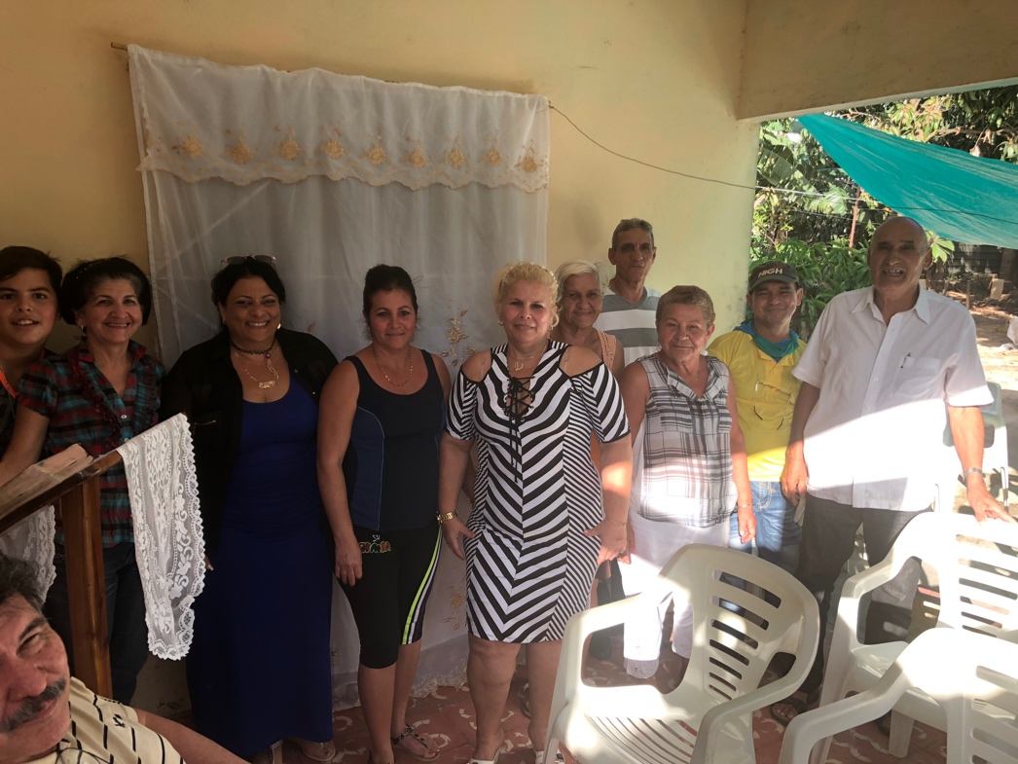
Close call in Santa Gertrudis… House church in Colon

Finally, on Monday of the trip, we celebrated the accomplishments of 14 TIBI students from various churches of Matanzas—finishing 15 courses while serving in the congregations, and receiving a special document called the “Certificate of Christian Service”. Many of these were retired people, some struggling with health issues, one illiterate streetsweeper—but all with hearts tender to others, minds open to learn, and hands ready to serve. Some of them had been studying since the first night after I went to Cuba more than five years ago—1939 days of perseverance and love for the Lord! It was a truly gratifying and humbling experience that underscored yet other ways in which our experience Cuba has been unique.
In case you missed it…
Some of you may not have received our year-end letter, so I thought I would share some updated facts and figures from our various programs.
- There were 514 baptisms in 2017 at sites where TIBI helps train leaders, making a total of 3150+ since 2009. There have been 54 more this year already.
- Four new churches were planted in 2017, and two more already this year.
- Our YouTube channel has more than 520,000 views (about 3,650,000 minutes!) and 4773 subscribers.
- During our 6th sponsored Israel trip in June, we were able to film clips for more than 50 teaching videos in English and Spanish, in a new 360-degree format, available on our channel of IBIT on YouTube (course #777).
- We enjoyed our largest number of graduates, incoming students, and total students, with a net growth of 700 students from last December.
- TIBI now has almost 2600 students total across our three platforms of live video conferencing, online courses, and local Bible schools. About 975 of these are in Cuba.

As always, we ask for your prayers that God will guide us, open doors, and bless us spiritually, physically, and financially.

Texas International Bible Institute
1502 Avenue I
South Houston, TX 77587

