The TIBI
HERALD
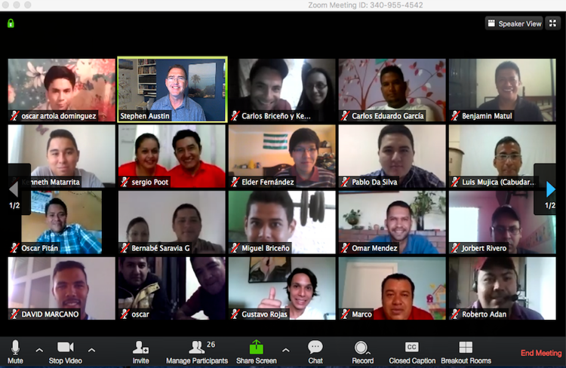

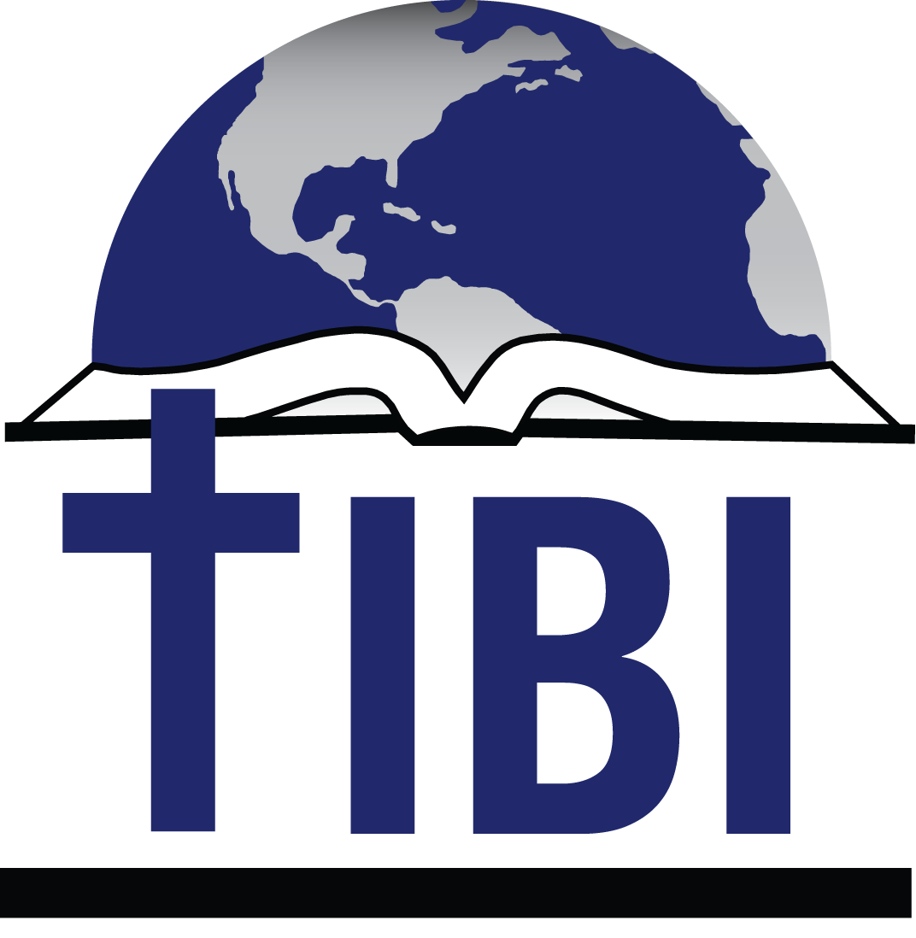

Editor
Steve Austin
Volume 16, Issue 2
July 1, 2019

THIS ISSUE

New opportunities in Austria
7th Holy Land trip

“…I looked, and there before me was a great multitude that no one could count, from every nation, tribe, people and language, standing before the throne…”

Rev. 7:9

Texas International

Bible Institute

P.O. Box 1501

1502 Avenue I

South Houston, TX 77587
(713) 910-2819

Online video courses at es.sunsetonline.org
YouTube IBIT

kevin@texasbible.org

austin@ibitibi.org
www.ibitibi.org
www.redinbi.org (Masters)
New Opportunities in Austria
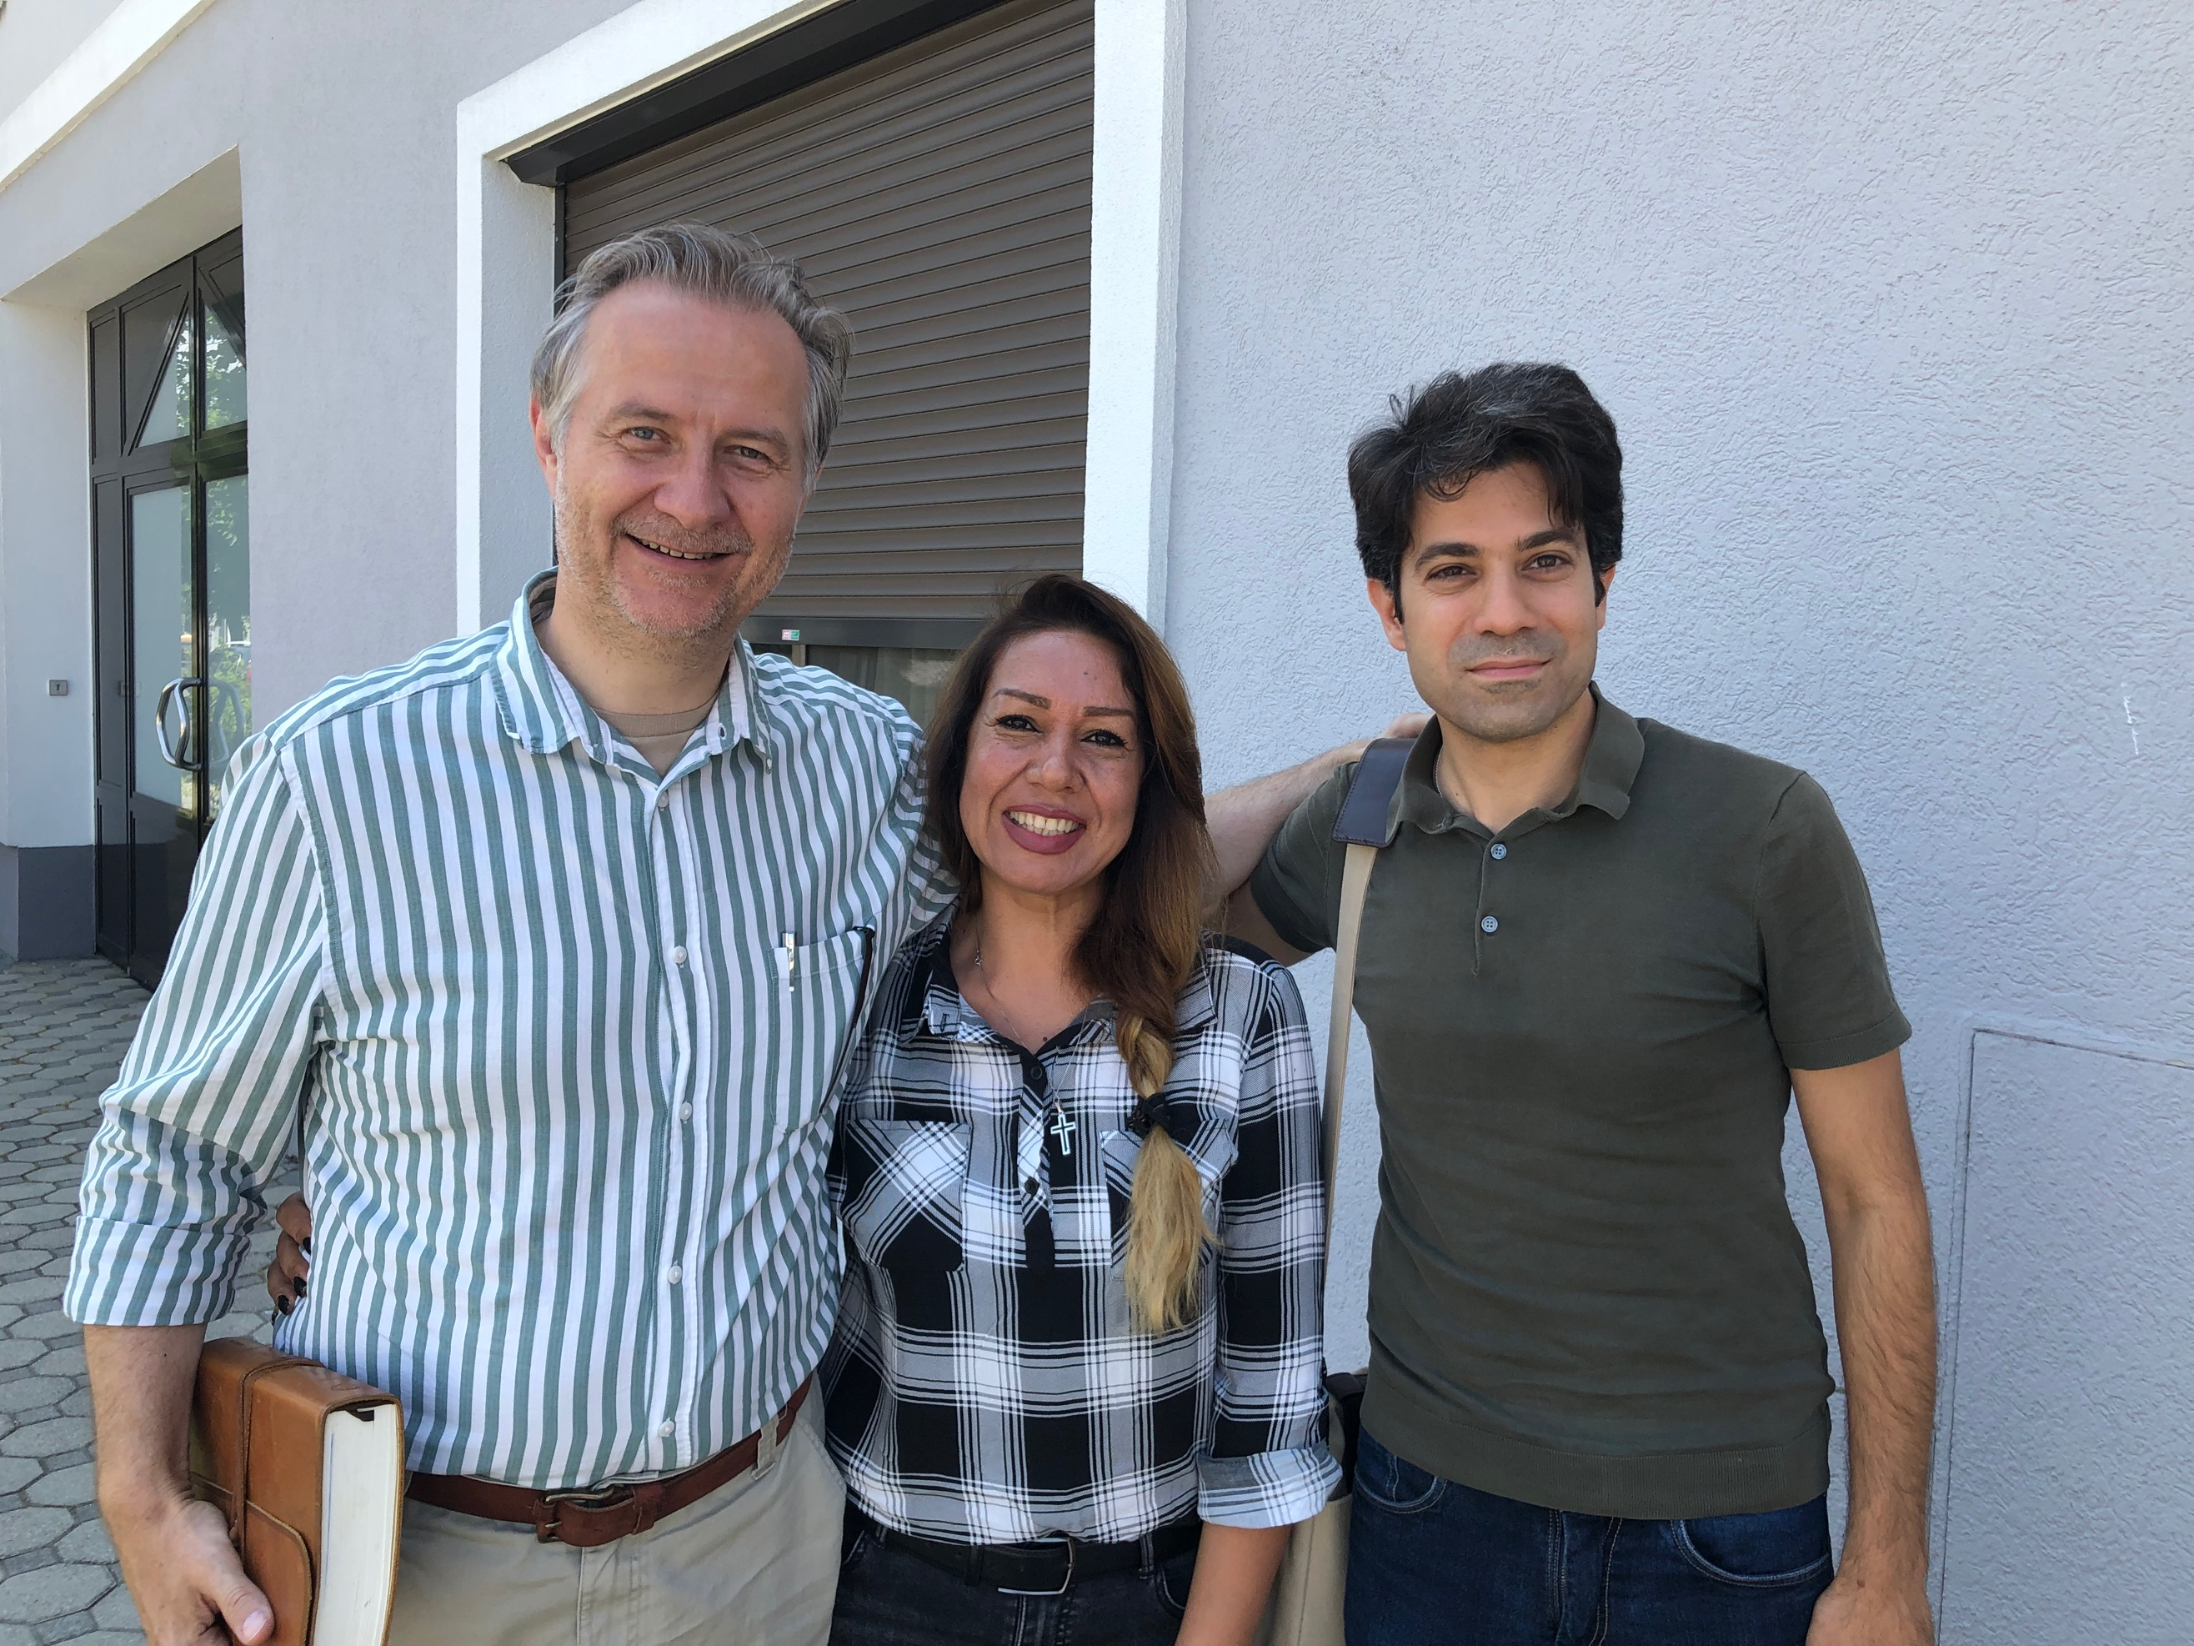
L to R: Gerhard Krassnig, Aram Ghadirian, Farshad Shirazi

In the last year or so, TIBI has been watching with interest what the Lord has been doing among the millions of refugees streaming out of Iran, Iraq, Syria, Jordan, Afghanistan, and many African countries, among others.
Many of these arrive in cities around the Mediterranean Rim, such as Athens, where they are given emergency help with food, clothing, and medical issues. In the process, Christians there share the gospel with them, and thousands are converting to Christianity.
As TIBI learned more about refugee ministries in several places, we asked, “What is the greatest need you are facing as you try to work with these refugees?”
Several of them responded, “We need ways to disciple and train new Christians, so they can grow and become independent in their faith, and we can develop new leaders from these groups who can train others.”

They elaborated, “Many are converting to Christianity from Islam, and it is a big change. They receive the gospel with joy and are baptized. They are eager to learn and take all the materials they can to study. But often there is no one to follow up and disciple them to maturity.”
Most refugees then are resettled into other countries such as France, Germany, Italy, and Austria, or wherever they are received—an increasingly difficult proposition. They lose contact with those who taught and mentored them. They seek community in the new country and naturally find other Muslims in their cities. Without continual training and mentoring, up to 90% go back into Islam.
When we heard the need for training in Bible and Christian living, and a way to stay connected to teachers and translators at a distance, no matter where they live, we said, “That’s what TIBI does!” We have years of expertise in training and connecting and discipling, all at a distance.
So we began speaking to people at MRN, Hellenic Ministries, and leaders in Austria, Greece, and Germany, to see how we might offer help. We developed a 14-week interactive course about what it means to be a Christian, and a Christian named Farshad Shirazi did a great job of translating it to Farsi, to make it available for people from Iran.
Then we started a small pilot group to see how it would work, with me (Steve Austin) teaching it one hour a week by Zoom from my home and Farshad translating to people connected from various places in Austria. Then a second, slight bigger group wanted to participate, so they began two months later.

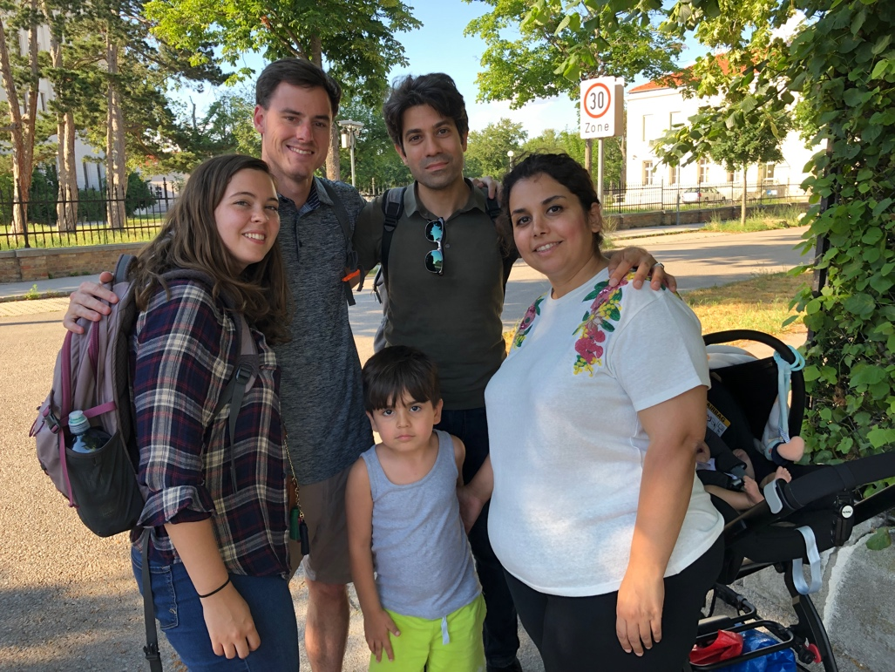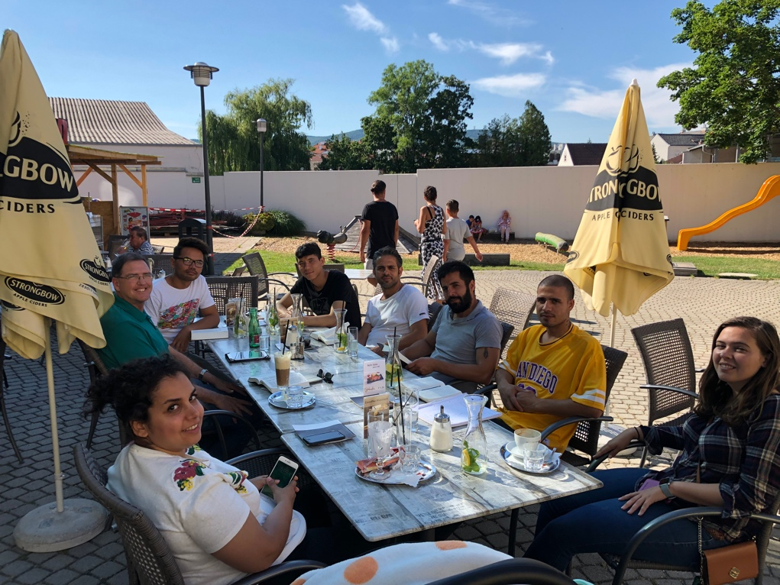
Drew and Elena, Farshad and Maryam Traiskirchen study group near refugee camp

In late June, after our Israel trip (see below), I flew directly to Vienna, Austria, where there is an active, fruitful ministry to the refugees. You may have seen the Christian Chronicle article that was partly about them. I met Gerhard and Susan Krassnig, and Farshad and his wife Maryam and family, as well as interns Drew Lambert and Elena McLaughlin, who all work with this ministry. I had already met Reggy Hiller, a long-time worker in Vienna and this ministry as well.
During five days there, I saw new Christians from Iran and Afghanistan in Bad Kreutzen, Traiskirchen, and Deutschkreutz, as well as Vienna. We shared Bible studies, worship, conversations, and coffee. Farshad did a wonderful job with translation and orientation. Gerhard and Susan made me feel welcome in their home and helped me learn about the history, goals, activities, and people of the refugee work in Austria.

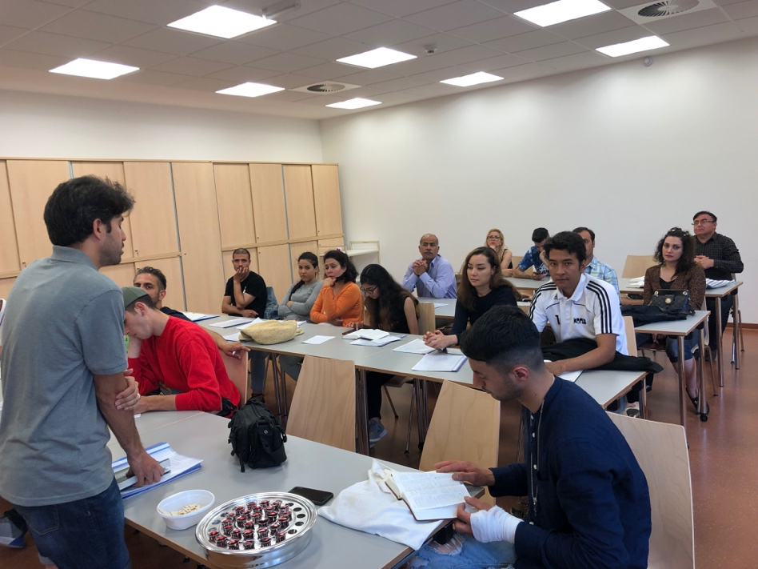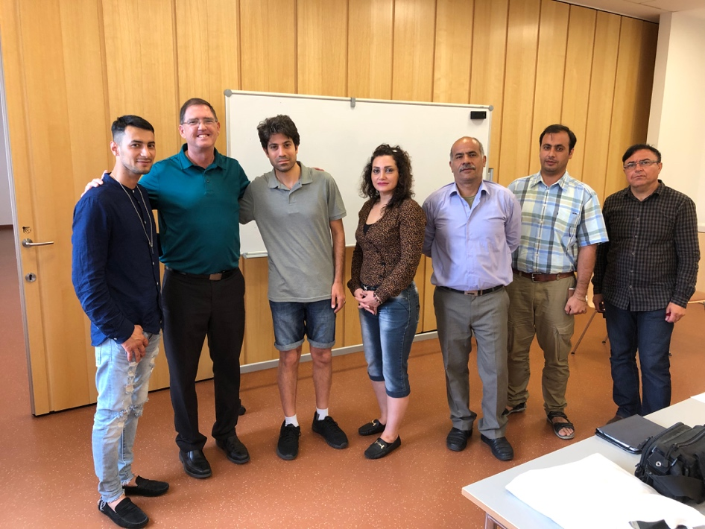
Sunday worship service at Traiskirchen Some members of TIBI classes in Austria

I am impressed with what I have seen, and I believe this is only the beginning, both with the work here and in other countries. There are many opportunities, paired with significant challenges in all aspects of the work. But God is doing amazing things, if we are willing to watch and participate.
If you’d like to learn more about the work in Austria, you can go to their website and be added to their newsletter list, at www.cocrefuge.network. You can also go to the websites for Missions Resource Network, Hellenic Ministries, and Eastern European Ministries.

Seventh Holy Land trip!
From June 6-19, TIBI hosted its seventh trip to the Holy Lands, this time going to Israel and Jordan. Brent Isbell and Steve Austin were the tour leaders. It was our largest group ever at 42 people, but things went very smoothly. People enjoyed the community built while touring, traveling, eating, and sharing together.

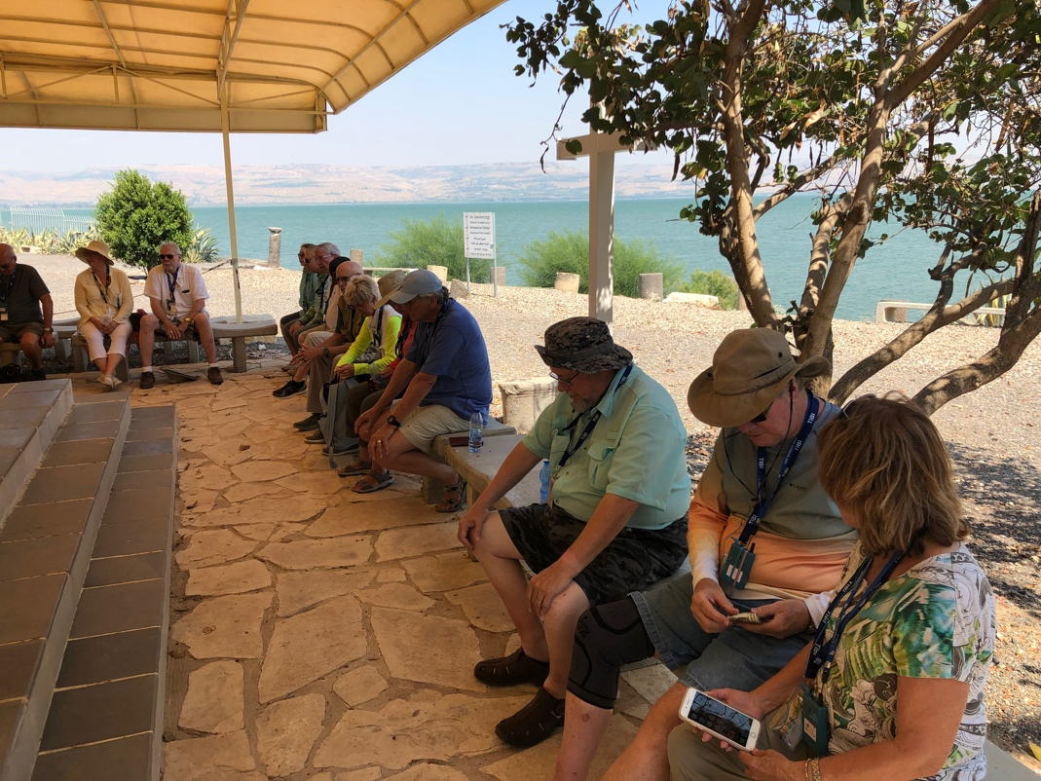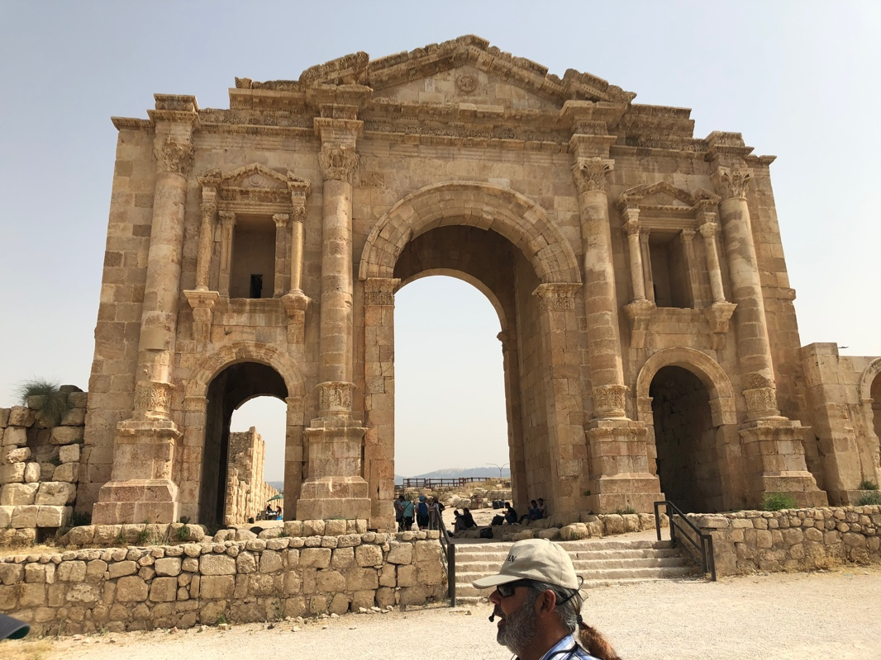
Sunday worship at Capernaum, by the Sea Hadrian’s Arch at Jerash

As usual, we tried to pack each day with as many opportunities to experience biblical lands, while reading and/or teaching at each site. We spent about 3 days in Jordan, including one major new site there at Jerash (biblical Gerasa). We saw Mount Nebo, Petra, and much of the landscape from northern to southern Jordan.
Then we came across to Israel for the Dead Sea and sites around it like Masada, En Gedi, and Qumran. We added Arad as a relatively new site, and drove through much of Judea on our way to Jerusalem, where we saw all the major sites such as Calvary, the Garden of Gethsemane, the Mount of Olives, the City of David, and Hezekiah’s tunnel, as well as places near it like Bethlehem and Herodion.
We drove up to Galilee for the last three days, enjoying Megiddo, Nazareth, Beth Shean, and major sites around the Sea like Capernaum, Magdala, Chorazin, and the Mount of Beatitudes. We rejoiced when three people were baptized for the first time in the Jordan River, and eight more did a baptism of renewal and rededication. We went north for Dan and Banyas, and west for Mount Carmel and Caesarea Maritime.
We were worn out and saturated with knowledge and new experiences by the end of the trip, but had a wonderful time. Lord willing, we hope to plan our next Israel trip for June 2021—so if you’re interested, let us know at slaustin@cebridge.net or brentisbell63@gmail.com. There are already about 54 people who have expressed interest in going!

Texas International Bible Institute
1502 Avenue I
South Houston, TX 77587

