The TIBI
HERALD
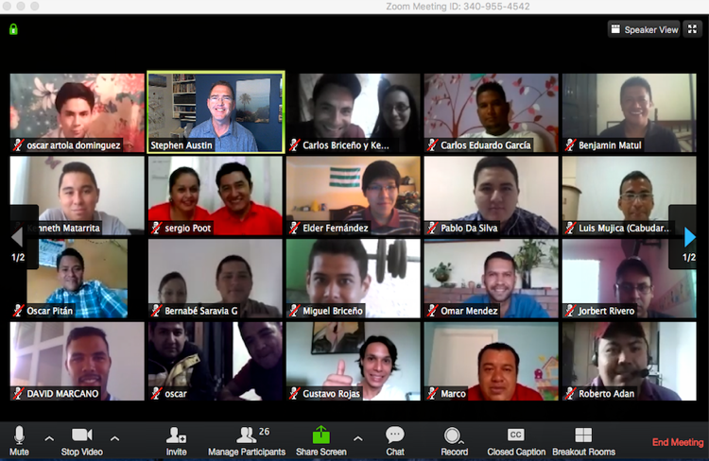

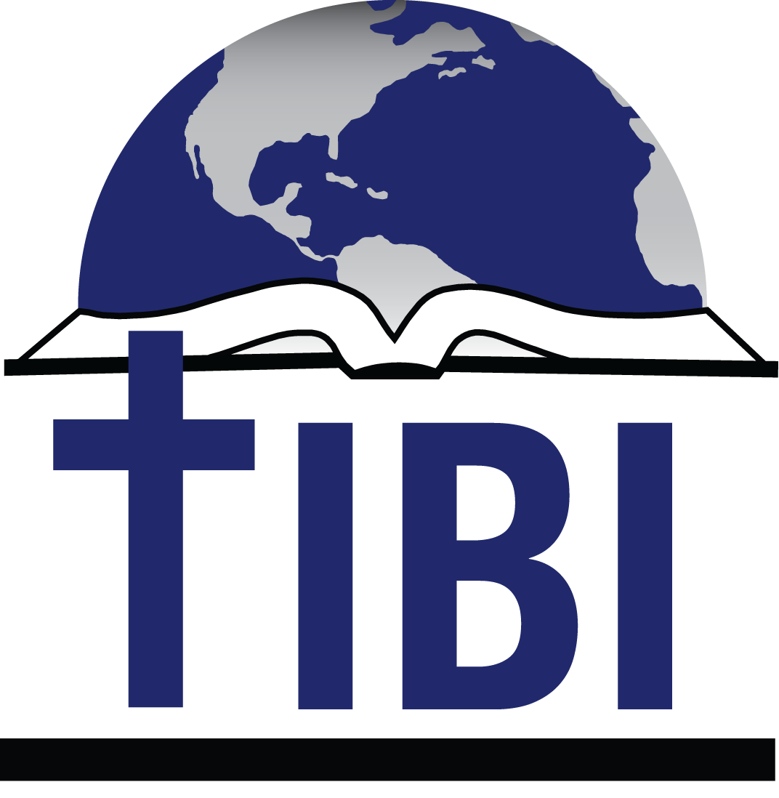

Editor
Steve Austin
Volume 16, Issue 1
April 4, 2019

THIS ISSUE

An Example in Perseverance
On track
A first in Cuba
Exciting EBL growth

“Praise be to the God and Father of our Lord Jesus Christ, the Father of compassion and the God of all comfort, who comforts us in all our troubles…”

2 Cor. 1:3-4

Texas International

Bible Institute

P.O. Box 1501

1502 Avenue I

South Houston, TX 77587
(713) 910-2819

Online video courses at es.sunsetonline.org
YouTube IBIT

kevin@texasbible.org

slaustin@cebridge.net
www.ibitibi.org
www.redinbi.org (Masters)
An Example in Perseverance
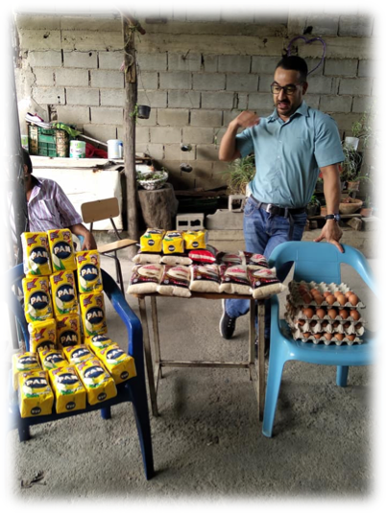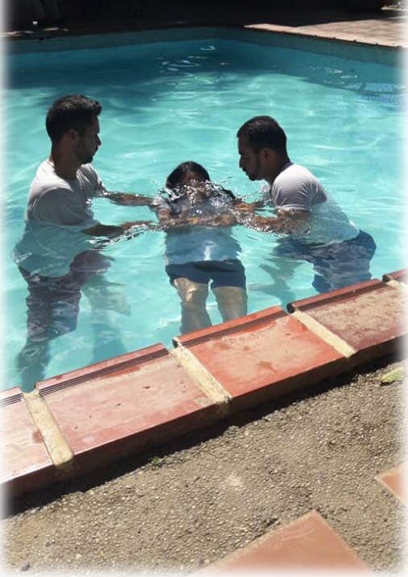
Activities of the Los Sauces congregation in Barquisimeto, Venezuela
(food distribution, left, and baptisms, right)

If you have been following the news the last several years, you know of the extremely difficult situation in the country of Venezuela. High unemployment, crumbling infrastructure, inflation of over 1 million percent last year, political and humanitarian troubles—all these have led to an ongoing crisis for everyone there, as well as the surrounding countries.
We don’t know the solution for these problems, but we can say with conviction and gratitude that we admire the attitudes and actions of the Venezuelan Christians and leaders in many locations across the country. We are in daily contact with them and can testify to their amazing perseverance in the face of these crippling challenges.
Our students regularly go hours daily without electricity, sometimes two or three days at a time. Even if there is electricity, the internet is weak or inconsistent. Since our courses are through live video conferencing or online courses, this is difficult for the students. They have to catch up on the classes missed on strange schedules—one man gets up at 3 AM to watch whatever he has had to miss, to have less congested internet traffic.

Others connect through their cell phones, when the electricity is out or their laptop battery dies. Some use car batteries in the neighborhood to recharge their phones or laptops! Or they tell us what is happening through WhatsApp on their phones. Drinking water is scarce, as are food and medicines. Even when available they are very expensive.
We feel helpless while watching this. Money is not useful in confronting some of these problems. We pray, we stay in touch, we try to adjust and encourage however we can.

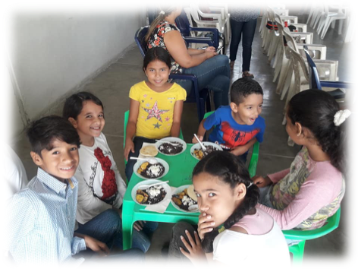 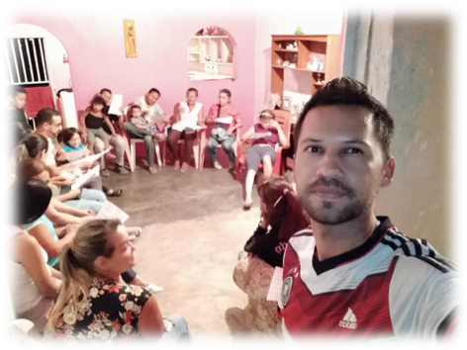 .…the Kingdom belongs to such as these… Omar Mendez, minister and TIBI student

Yet it’s amazing to see how the Venezuelan Christians are persisting in giving a faithful witness to a loving God, in spite of the physical and spiritual darkness.
- In a country where people are robbed and attacked daily everywhere, Christians are giving away food and medicines.
- In a society where anger and apathy abound, Christians remain united in serving the weak and helpless, the children and the aged.
- In places where many have given up on life, Christians are sharing the message of eternal life in Jesus, and many are coming to faith.
- The church has grown remarkably in the face of all this, much like the church in times of frequent persecution. In the darkness, the light of Jesus really is shining.

We are proud to know these brothers and sisters and work with them. Please pray for them to continue to be faithful and productive.

On Track
In an effort to diversify and tailor what we offer to individuals and congregations, TIBI has created three new tracks of study.
The first track is called the Christian Worker certificate (Obrero Cristiano), consisting of 16 courses, including a mix of OT, NT, and ministry skills courses. This was developed through our Cuban program. Liudmila Fernandez has already helped 35 students graduate with this certificate there.
The second is the Ministry track, consisting of 12 courses specializing in ministry skills, for those working in various ministries of the local church. Third, we offer the Biblical Studies certificate for those wishing to develop the tools to study the Bible at a more detailed level. This entails taking 23 courses—16 concerning the OT and the NT, plus Hebrew, Greek, exegesis, and hermeneutics.
Our full-time students, of course, take all of our 40 courses on their way to the Bachelor of Biblical Studies degree. We have recently learned that with this degree, our graduates now can be accepted into masters’ programs at Abilene Christian University, Harding, and Fuller Theological Seminary, among other possibilities.
If you know of missionaries, ministers, or churches who might be able to benefit from these programs, please let us know, and we can contact them. They can take these courses from anywhere in the world.

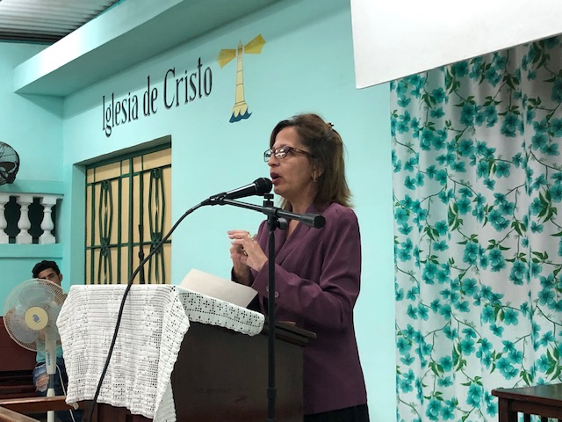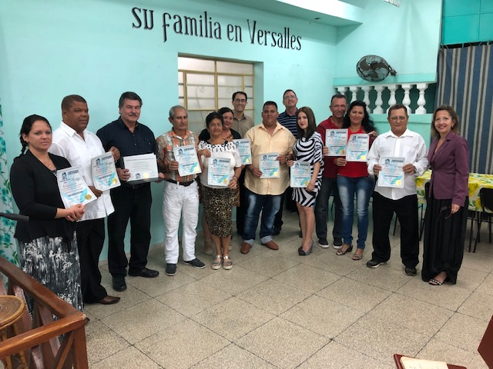
Liudmila Fernandez Most recent Cuban Obrero Cristiano graduates

A First in Cuba
We recently returned from Cuba, where we conducted a seminar for about 30 church leaders, as well as visiting with Christians from all over the country. While there, our coordinator of TIBI’s program, Liudmila Fernandez, told me that TIBI now has more than 5800 students in Cuba! This means that worldwide, TIBI has about 8000 students now.
Liudmila gave us two diplomas to sign while there. She said that these two students had completed all 40 courses on their own; that is, not as a part of an established group of students. This is difficult to do, and as far as I know, these are the first two students in the world to have completed our degree in this fashion. It has taken about 10 years to make these courses available, so to see students who have taken advantage of the opportunity is gratifying to us. We applaud their persistence and dedication.

Exciting EBL Growth!
Our Escuelas Bíblicas Locales (Local Bible Schools) continue to develop in useful and surprising ways. These schools form when our graduates or other church leaders desire to establish a small TIBI branch in their churches or cities. We supply them with the courses and materials and give them the orientation and oversight to begin the work. We have had as few as 3 or as many as 45 students in a place, depending on the church.
We mention two of these in particular—the EBL hosted by Oscar Pitán and the Villa Nueva church in Guatemala City, Guatemala; and the EBL hosted by Bernabé Saravia and the Tipitapa Centro church in Managua, Nicaragua. These men have developed a hybrid format where our video courses are supplemented by live Zoom video conferencing and also learning management systems like Edmodo and Canvas. In this way they work with students not only at their churches but all over their countries. They combine the best of independent and also group learning and support.
They offer their students a variety of tools that make learning more convenient and accessible. And they are coordinating all this themselves, independently of us, while keeping us informed. For me, this combination of talented people, cutting-edge technology, our resources, and their hard work and initiative, is extremely exciting. It is a real example of the training and development which is possible with these kinds of people and churches. Please pray for their development!

Texas International Bible Institute
1502 Avenue I
South Houston, TX 77587

